**Institute of Technology Tralee**

**BSc. in Computing with Specialism (Group A) - Year 1**

**Continuous Assessment #1**

**Date: 18/10/11**

**Time: 10 – 12 p.m.**

**Introduction to Programming**

**Instructions:** Attempt the following question. You should use the Just BASIC IDE for coding. When you are finished you must print out your code for correction.

**________________________________________________________**

**Q1.**

Write a Just BASIC program that determines the period of a planet, which is the time taken for it to complete one full rotation of its orbit.

The period, T, of the planet is given by Keplar’s 3rd law of planetary motion which states:

where

•r is the radius of the planets orbit in metres

•G is the universal gravitational constant, whose value is 6.67428 x 10-11

•m is the combined mass of the planet and the body it is orbiting in kilos

•π is the number pi, whose value can be set to 3.142 for the purposes of this exam

You should **create variables** for G and π in your program and set them accordingly.

The program should request the user to supply values for the radius of the orbit and the combined mass of the planet/body it orbits and, provided that these values are both valid, then use the formula above to calculate the corresponding period in seconds.

If it turns out that the radius value entered is invalid (less than zero) then an appropriate message indicating this should be displayed and the program should immediately terminate (without even asking for the combined mass value or doing any calculations)

Likewise, if it turns out that the combined mass value is invalid (less than zero) then an appropriate message indicating this should be displayed and the program should immediately terminate (without even attempting to do any calculations)

Provided that both the radius and combined mass values are valid, the period should then be calculated and displayed correct to **3 decimal places**. Also the program should allow for **at least 10 digits to be displayed** before the decimal point without incurring a logical error.

The program should also display the period in days to **the nearest day**. Use the fact that there are 86400 seconds in a day to perform the conversion here.

Using the test values as indicated in the sample screen shots below, the program should give you **exactly** the following output when it runs, including banners, blank lines, units etc. Note in the last screenshot that there are 10 zeroes in the valid radius and 25 zeroes in the valid mass values entered.

Also note that there will be a few marks awarded for the use of **meaningful variable names**, having a **meaningful comment at the top of the program** and for **proper indentation** in the coding of the program. Also, some marks will be awarded for **efficient** coding and for ensuring that the program is terminated correctly to ensure that all resources used by the program are returned to the system upon its completion.

**Sample Screen Shots**

**In this run the radius value is invalid:**

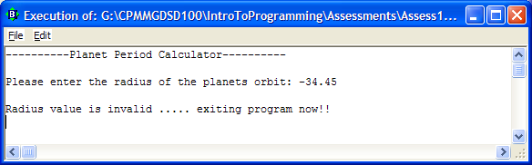

**In this run the combined mass value is invalid:**

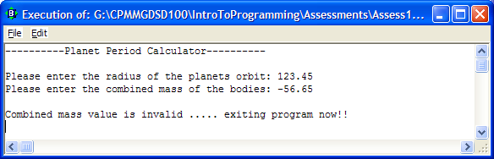

**In this run both the radius and combined mass values are valid:**

